**Year 8 HASS 2023- Economics and Business**

**Assessment 3 – Case Study (7.5%)**

|  |  |
| --- | --- |
| **HUMANITIES & SOCIAL SCIENCES ASSESSMENT TASK** | |
| **Year level** | 8 |
| **Subject** | Economics & Business |
| **Title of task** | Assessment 3: Case Study – Impact of Technology on Agriculture? |
| **Weighting** | 7.5% |
| **Description of task** | This assessment has two parts:  **Part A (5%):** Students will spend *two lessons in class* using a provided graphic organiser to make notes based on a news article.  **Part B (2.5%):** Students will complete an in-class validation (*one lesson*) with short answer questions based on the article and the way that producers must respond to the demands of consumers. They will be allowed their note-taking sheet for this. |
| **Suggested time** | * 3 lessons in class |
| **DOCUMENTATION** | |
| **Documentation** | * Copy of news article * Note-taking template (A3) * Validation |
| **TEACHER FEEDBACK** | |
| **MARK:**  _____/80 | |

**Name: __________________________________**

## Instructions:

*Note: You will have two lessons in class to complete this part of the task.*

1. Before reading the article, make notes on your A3 note-taking sheet on how you think the agricultural industry has been impacted by technology
2. Read the ABC news article titled *‘Coronavirus shifts consumer behaviour and helps some businesses boom’* by Nassim Khadem. A copy is provided in this booklet for you (Pg 3). Take notes on your A3 sheet based on how different technological advancements and COVID-19 has impacted the agricultural industry.

## Part A: Marking Key

|  |  |  |  |  |  |
| --- | --- | --- | --- | --- | --- |
|  | **How technology could benefit agriculture** | **Examples of technology that is being used in agriculture** | **Impact of COVID-19 on agricultural industry** | **0** | **Subtotal** |
| **Before Reading**  **Section** | 1 mark limited notes  2 marks adequate notes  3 marks detailed notes | 1 mark for listing  2 marks for listing and outlining  3 marks for list and explanation | 1 mark limited notes  2 marks adequate notes  3 marks detailed notes | No notes are submitted (0) | /9 |
| **After Reading** | **3** | **2** | **1** | **0** | **Subtotal** |
| **Why agricultural industry will benefit from technology** | Detailed notes, Uses supporting evidence from the source such as statistics, quotes and examples of businesses. | Adequate notes, Uses mostly relevant supporting evidence from the source such as statistics, | Limited notes, Uses some evidence the source, however there are some lapses in relevancy or accuracy. | No evidence is provided (0) | /3 |
|  | **Description** | **Benefits** | **Challenges** | **Economic Growth** | **Subtotal** |
| **Technology**  **(Name 1 mark)**  ***per technology.*** | 3 marks for detailed description. 2 marks for outlining. 1 mark for identifying. | 3 marks for detailed description. 2 marks for outlining. 1 mark for identifying. | 3 marks for detailed description. 2 marks for outlining. 1 mark for identifying. | 3 marks for detailed description. 2 marks for outlining. 1 mark for identifying. | /65 |
|  | **3** | **2** | **1** | **0** | **Subtotal** |
| **IMPACT of COVID on agricultural industry** | Detailed notes, Uses supporting evidence from the source such as statistics, quotes and examples of businesses. | Adequate notes, Uses mostly relevant supporting evidence from the source such as statistics, | Limited notes, Uses some evidence the source, however there are some lapses in relevancy or accuracy. | No evidence is provided (0) | /3 |

**Total Score:** ________ / 80

News Article

**Adapted from:** Agricultures connected future: How Technology can yield new growth. https://www.mckinsey.com/industries/agriculture/our-insights/agricultures-connected-future-how-technology-can-yield-new-growth

**Agricultures Connected Future: How Technology can yield new growth.**

One of the oldest industries must embrace a digital, connectivity-fuelled transformation in order to overcome increasing demand and several disruptive forces.

The agriculture industry has radically transformed over the past 50 years. Advances in machinery have expanded the scale, speed, and productivity of farm equipment, leading to more efficient cultivation of more land. Seed, irrigation, and fertilizers also have vastly improved, helping farmers increase yields. Now, agriculture is in the early days of yet another revolution, at the heart of which lie data and connectivity. Artificial intelligence, analytics, connected sensors, and other emerging technologies could further increase yields, improve the efficiency of water and other inputs, and build sustainability and resilience across crop cultivation and animal husbandry.

Without a solid connectivity infrastructure, however, none of this is possible. If connectivity is implemented successfully in agriculture, the industry could tack on $500 billion in additional value to the global gross domestic product by 2030, according to our research. This would amount to a 7 to 9 percent improvement from its expected total and would alleviate much of the present pressure on farmers. It is one of just seven sectors that, fuelled by advanced connectivity, will contribute $2 trillion to $3 trillion in additional value to global GDP over the next decade.Video

Demand for food is growing at the same time the supply side faces constraints in land and farming inputs. The world’s population is on track to reach 9.7 billion by 2050, requiring a corresponding 70 percent increase in calories available for consumption, even as the cost of the inputs needed to generate those calories is rising. By 2030, the water supply will fall 40 percent short of meeting global water needs, and rising energy, labor, and nutrient costs are already pressuring profit margins. About one-quarter of arable land is degraded and needs significant restoration before it can again sustain crops. And then there are increasing environmental pressures, such as climate change and the economic impact of catastrophic weather events, and social pressures, including the push for more ethical and sustainable farm practices, such as higher standards for farm-animal welfare and reduced use of chemicals and water.

To address these forces poised to further roil the industry, agriculture must embrace a digital transformation enabled by connectivity. Yet agriculture remains less digitized compared with many other industries globally. Past advances were mostly mechanical, in the form of more powerful and efficient machinery, and genetic, in the form of more productive seed and fertilizers. Now much more sophisticated, digital tools are needed to deliver the next productivity leap. Some already exist to help farmers more efficiently and sustainably use resources, while more advanced ones are in development. These new technologies can upgrade decision making, allowing better risk and variability management to optimize yields and improve economics. Deployed in animal husbandry, they can enhance the well-being of livestock, addressing the growing concerns over animal welfare.

But the industry confronts two significant obstacles. Some regions lack the necessary connectivity infrastructure, making development of it paramount. In regions that already have a connectivity infrastructure, farms have been slow to deploy digital tools because their impact has not been sufficiently proven.

The COVID-19 crisis has further intensified other challenges agriculture faces in five areas: efficiency, resilience, digitization, agility, and sustainability. Lower sales volumes have pressured margins, exacerbating the need for farmers to contain costs further. Gridlocked global supply chains have highlighted the importance of having more local providers, which could increase the resilience of smaller farms. In this global pandemic, heavy reliance on manual labour has further affected farms whose workforces face mobility restrictions. Additionally, significant environmental benefits from decreased travel and consumption during the crisis are likely to drive a desire for more local, sustainable sourcing, requiring producers to adjust long-standing practices.

Connectivity’s potential for value creation

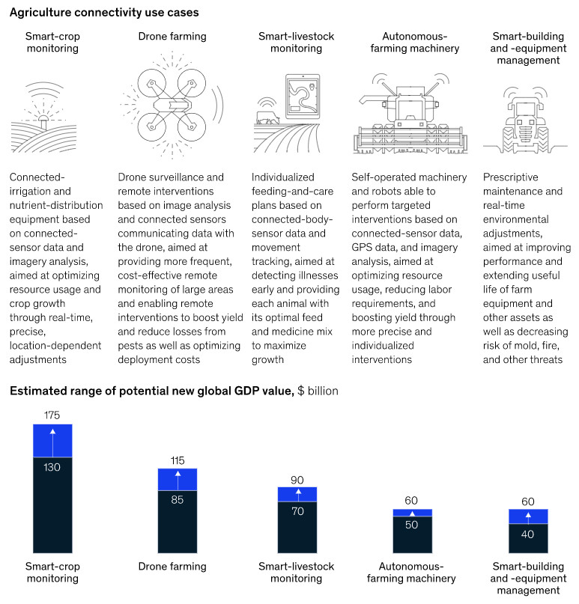By the end of the decade, enhanced connectivity in agriculture could add more than $500 billion to global gross domestic product, a critical productivity improvement of 7 to 9 percent for the industry.



Use case 1: Crop monitoring

Connectivity offers a variety of ways to improve the observation and care of crops. Integrating weather data, irrigation, nutrient, and other systems could improve resource use and boost yields by more accurately identifying and predicting deficiencies. For instance, sensors deployed to monitor soil conditions could communicate via bluetooth, directing sprinklers to adjust water and nutrient application. Sensors could also deliver imagery from remote corners of fields to assist farmers in making more informed and timely decisions and getting early warnings of problems like disease or pests.

Smart monitoring could also help farmers optimize the harvesting window. Monitoring crops for quality characteristics—say, sugar content and fruit color—could help farmers maximize the revenue from their crops.

Most networks today cannot support imagery transfer between devices, let alone autonomous imagery analysis, nor can they support high enough device numbers and density to monitor large fields accurately.

Use case 2: Livestock monitoring

Preventing disease outbreaks and spotting animals in distress are critical in large-scale livestock management, where most animals are raised in close quarters on a regimen that ensures they move easily through a highly automated processing system. Chips and body sensors that measure temperature, pulse, and blood pressure, among other indicators, could detect illnesses early, preventing herd infection and improving food quality. Farmers are already using ear-tag technology from providers such as Smartbow (part of Zoetis) to monitor cows’ heat, health, and location, or technology from companies such as Allflex to implement comprehensive electronic tracing in case of disease outbreaks.

Similarly, environmental sensors could trigger automatic adjustments in ventilation or heating in barns, lessening distress and improving living conditions that increasingly concern consumers. Better monitoring of animal health and growth conditions could produce $70 billion to $90 billion in value by 2030.

Use case 3: Building and equipment management

Chips and sensors to monitor and measure levels of silos and warehouses could trigger automated reordering, reducing inventory costs for farmers, many of whom are already using such systems from companies like Blue Level Technologies. Similar tools could also improve shelf life of inputs and reduce post-harvest losses by monitoring and automatically optimizing storage conditions. Monitoring conditions and usage of buildings and equipment also has the potential to reduce energy consumption. Computer vision and sensors attached to equipment and connected to predictive-maintenance systems could decrease repair costs and extend machinery and equipment life.

Such solutions could achieve $40 billion to $60 billion in cost savings by 2030.

Use case 4: Farming by drone

Agriculture has been using drones for some two decades, with farmers around the world relying on pioneers like Yamaha’s RMAX remote-controlled helicopter to help with crop spraying. Now the next generation of drones is starting to impact the sector, with the ability to survey crops and herds over vast areas quickly and efficiently or as a relay system for ferrying real-time data to other connected equipment and installations. Drones also could use computer vision to analyze field conditions and deliver precise interventions like fertilizers, nutrients, and pesticides where crops most need them. Or they could plant seed in remote locations, lowering equipment and workforce costs. By reducing costs and improving yields, the use of drones could generate between $85 billion and $115 billion in value.

Use case 5: Autonomous farming machinery

More precise GPS controls paired with computer vision and sensors could advance the deployment of smart and autonomous farm machinery. Farmers could operate a variety of equipment on their field simultaneously and without human intervention, freeing up time and other resources. Autonomous machines are also more efficient and precise at working a field than human-operated ones, which could generate fuel savings and higher yields. Increasing the autonomy of machinery through better connectivity could create $50 billion to $60 billion of additional value by 2030.

Additional sources of value

Connected technologies offer an additional, indirect benefit, the value of which is not included in the estimates given in these use cases. The global farming industry is highly fragmented, with most labor done by individual farm owners. Particularly in Asia and Africa, few farms employ outside workers. On such farms, the adoption of connectivity solutions should free significant time for farmers, which they can use to farm additional land for pay or to pursue work outside the industry.